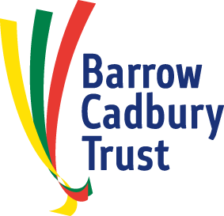

August 2018

Dear Applicant

**Post of Programme Officer**

Thank you for your interest in the post of Programme Officer with the Barrow Cadbury Trust. Please find attached the job description and person specification for this post.

The Barrow Cadbury Trust is an independent charitable foundation seeking a just and peaceful society which recognizes the equal value of all people. Largely working in partnerships with others, we use all our resources – our grants, our people and our name - to bring about structural change, thus increasing social justice and equality.

Based at our office in Kean House, 6 Kean Street, London WC2B 4AS the successful candidate will not only ensure our grant making systems run smoothly and the Director of Programmes is well supported but will also play a key role in helping to maximise the impact of our work: disseminating our learning, convening meetings and supporting wider communications. This post will suit someone with a passion for social justice, experience of setting up and running office systems and excellent organisational skills including database management.

This is a permanent contract. The salary scale is £30,000 - £32,000 p.a. The Trust offers a contributory pension scheme.

Any offer of employment will be made subject to references, confirmation of the right to work in the UK (see the information below relating to complying with the preventing illegal working legislation) and the satisfactory completion of a probationary period.

Before you apply please have a look at our website and view our short animation about our values and the way we work ([www.barrowcadbury.org.uk](http://www.barrowcadbury.org.uk)).

If you would like to apply for this position, please send us your CV and a covering letter setting out your skills and suitability for the post (no more than 3 sides of A4) to Maddy Rooke-Ley at [HR@barrowcadbury.org.uk](mailto:HR@barrowcadbury.org.uk) by **5pm on 9 September 2018**.

/1

//2

We will notify you if you have been short listed for interview by Tuesday 11 September at the latest. Interviews for short listed candidates will be held on **Friday 14 September 2018** at our office at Kean House, 6 Kean Street, London, WC2B 4AS. We have no flexibility for the interview date so please ensure you are available on 14 September should you be short listed.

We look forward to receiving your application.

Yours sincerely



**Sara Llewellin**

**Chief Executive**

Encs – Job description, Job Applicant Privacy Statement, complying with preventing illegal working legislation and Equal Opportunities Monitoring Form attached below